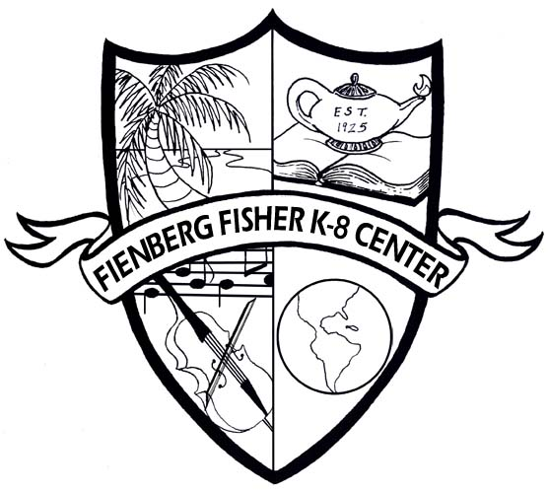

Fienberg-Fisher K-8 Center
IB World School

2013
Summer Home Learning Packet
for
Incoming Second Grade Students

Dear Parents/Guardians:

Over the summer, all students are required to read at least two books and complete the activities attached with this packet. When the students return to school they will be required to turn in the packet to their teacher. This will be their first two grades for the first nine weeks.

Required Reading with Activities:
The Little Engine That Could / Author: Watty Piper (IB)
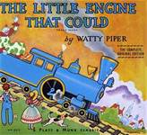

Click, Clack, Moo: Cows That Type/ Author: Doreen Cronin (IB)
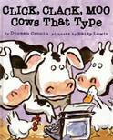

Recommended Reading:
Stella Luna Emily’s Art Un Leon en la Biblioteca
Author: Janell Colon Peter Catalanotto (IB) Author: Michelle Knudsen

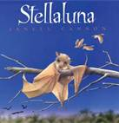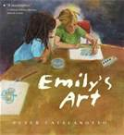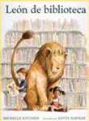
Dear 2nd grade students,

Please pick to read two of the books selected for the incoming 2nd graders and then choose one of the following activities for each book that you picked:

- Keep a reading log/journal of the books you have read. Include the title(s), a one-sentence summary of each and write two or three new words you have learned from your reading.

- Pick your favorite part of the story and draw of picture of that part. Then write to explain why that is your favorite part of the story.

- Rewrite the story in picture book form.

Have a great summer!!!!
From, your future 2nd grade teachers ☺

